**IE 544**

**DECISION ANALYSIS**

**Assignment 3**

**“How to Win Amazon’s Buy Box?”**



**By**

**Group ID: Q**

**Hande Mızrak**

**Burak Şimşek**

The main contention of this project is to understand and reveal the factors playing a significant role in winning the Buy Box. At first sight one can easily say that price information has a major influence on Amazon's Buy Box. To see the effect of other features such as seller ratings, shipping costs, product ratings, etc, some analysis on the training data is made and given below.

**1.**

|  |  |
| --- | --- |
| Number of Products (Overall) | 9 |
| Number of Sellers (Overall) | 184 |

The name of the products and the corresponding seller numbers for these products are the following:

|  |  |
| --- | --- |
| **Product Name** | **No. of Sellers** |
| B002ZV0OJO | 29 |
| B0083H1INK | 20 |
| B00AMFLZLG | 6 |
| B00DNSO1OW | 15 |
| B00DNSO41M | 21 |
| B00MVVI1FC | 38 |
| B00VSIT5UE | 44 |
| B00VSITBJO | 69 |
| B00YR6BMS2 | 23 |

The bar plot of the table given above is the following:

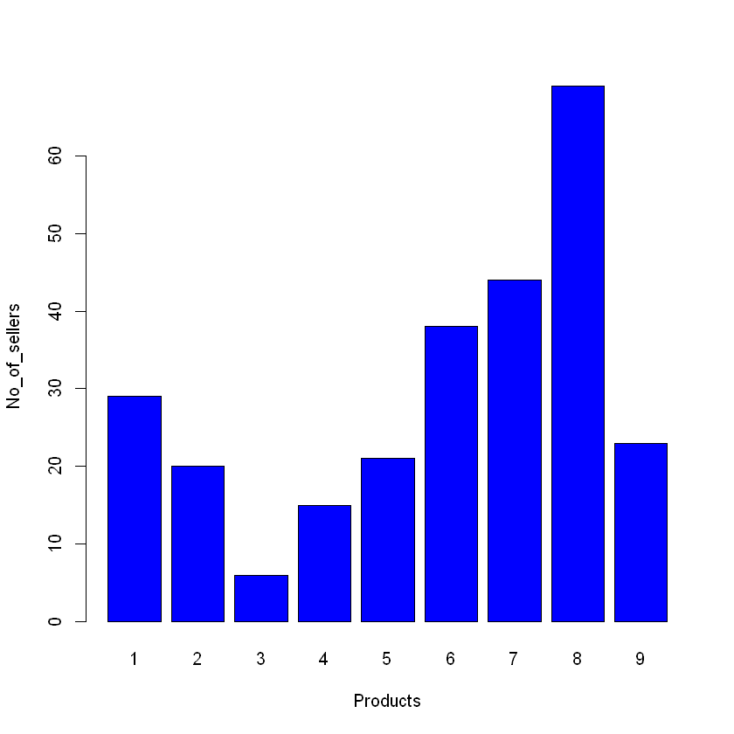

In our training data we have 23 days in total (from 08.11.2015 to 09.02.2015). The bar plots given below represent how the number of sellers and products change with respect to time which is day in our case.

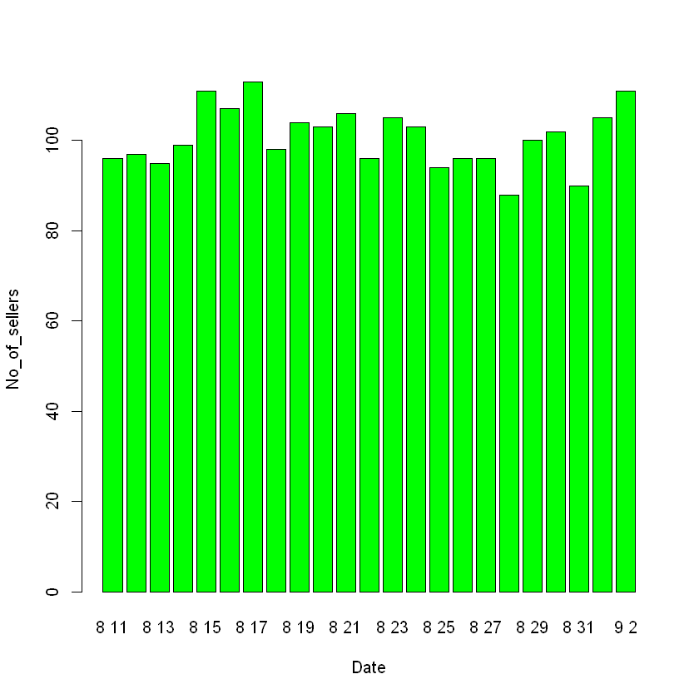

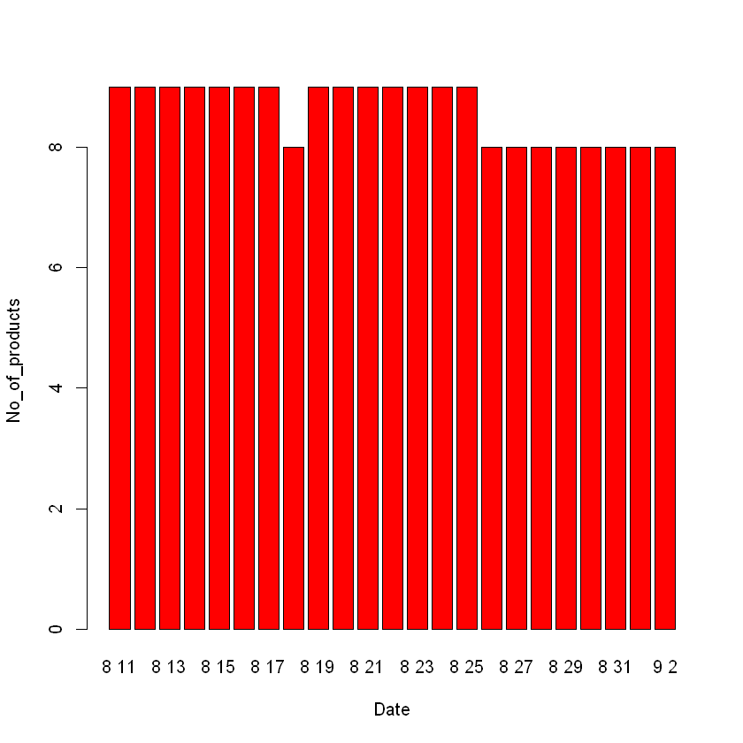

1. Before doing any calculation one can expect that average buy box price should follow min price since an algorithm which lets a seller to win offering a larger price compared to the other sellers for the same product is meaningless. The average, max, min, and average buy-box prices for each product are given below:

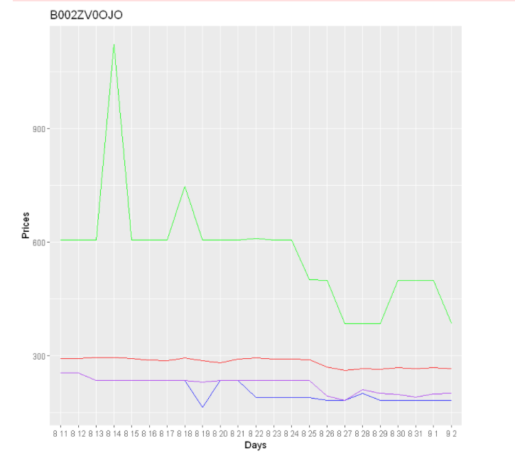 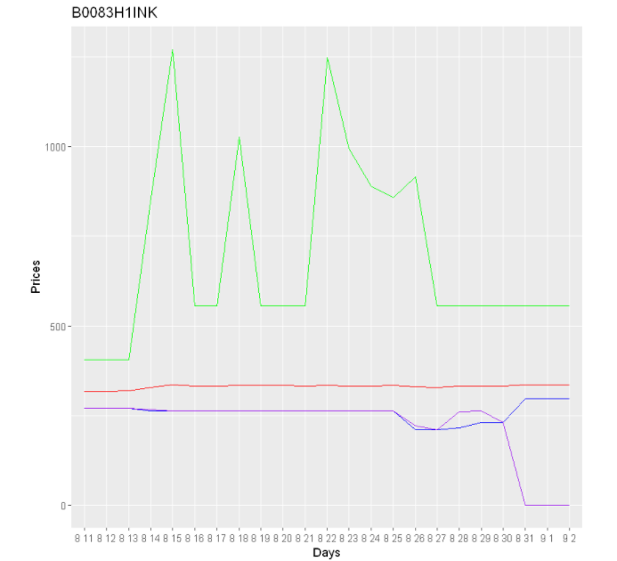

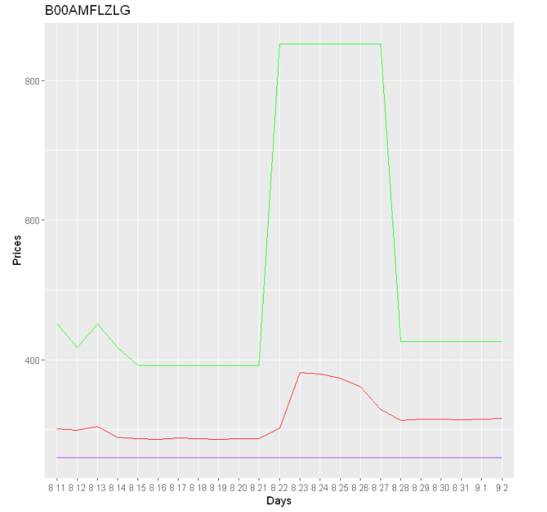 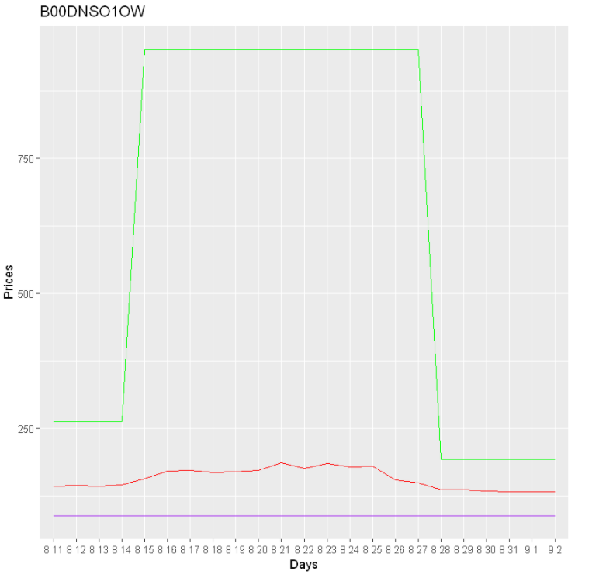

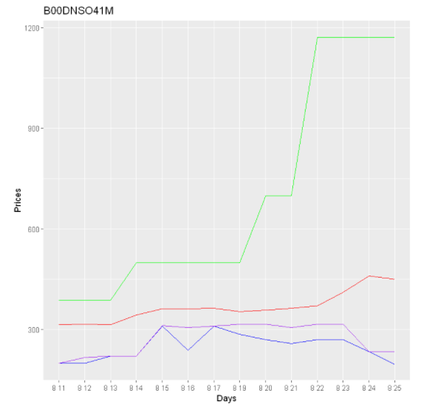 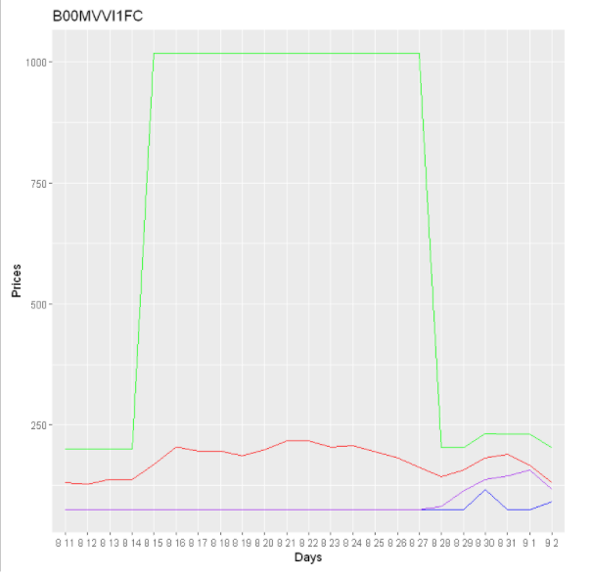

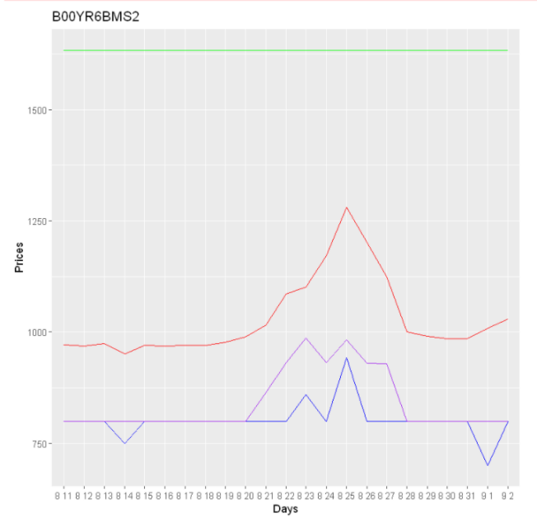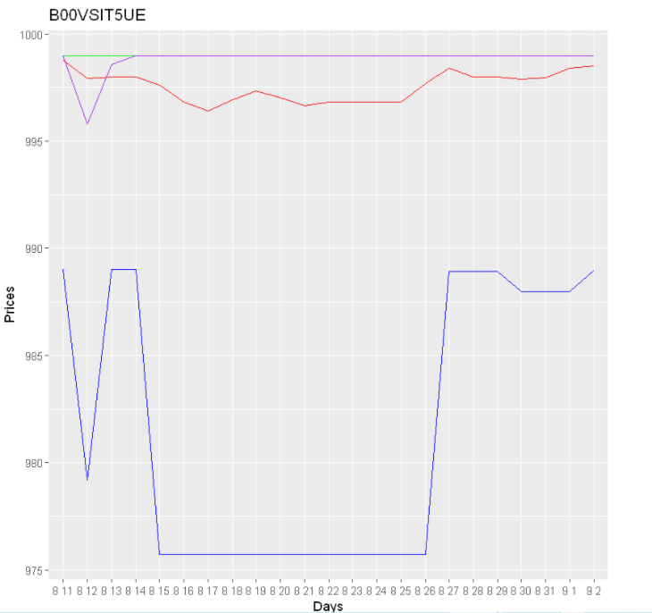 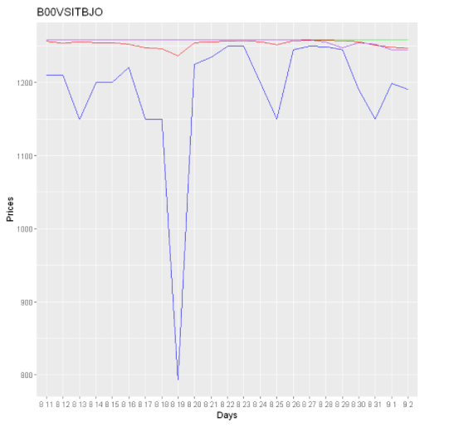

Blue, purple, green and red lines represent min price, average bbox price, max price and average price, respectively. As can be seen that the results agree with our first intuition for most of the products.The exceptions are product “B00VSIT5UE” and product “B00VSITBJO”. For these products bbox price is above the min price.

In addition, average shipping cost over time and by product are calculated as follows:

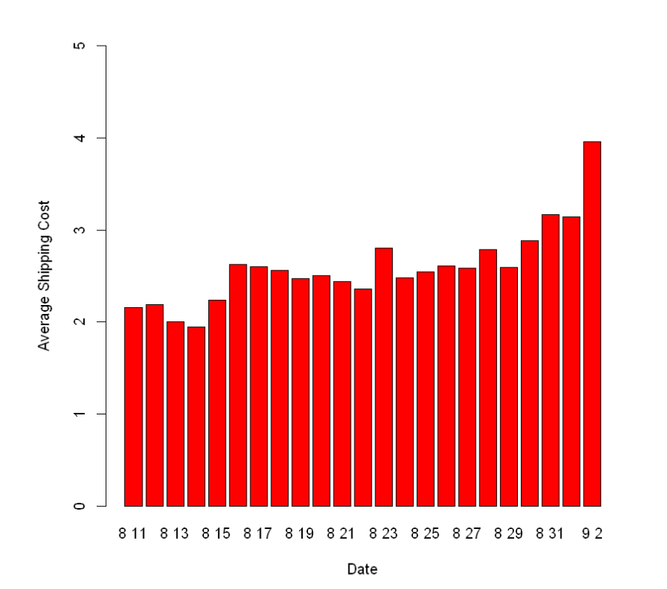 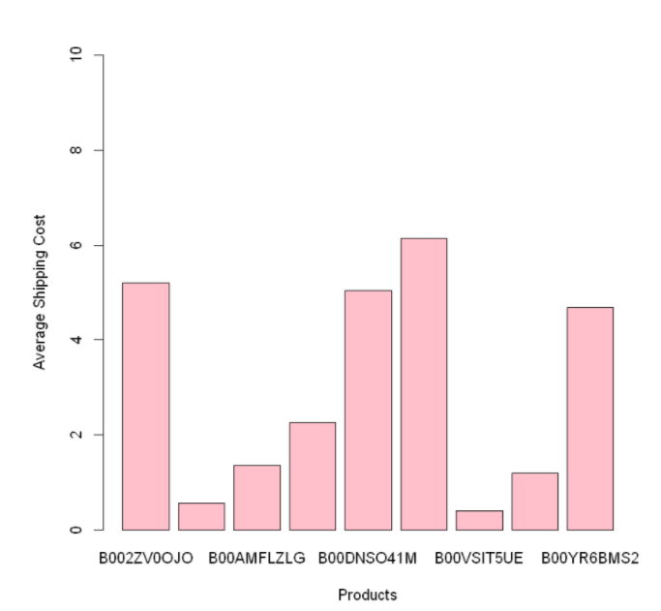

1. Since we do not have access to try the real products physically in the online shopping process, sharing customers’ experiences publicly and giving feedback about the seller and product have become more crucial than they used to be. In addition, they play a significant role in promoting the sellers. Therefore, it is a good idea to look at the seller ratings, seller rating counts and positive feedback values of sellers who appear in the buy box for each product. The average results are calculated as follows:

|  |  |  |  |
| --- | --- | --- | --- |
| **Product Name** | **Average Seller Rating for Bbox=Success** | **Average Seller Rating Counts for Bbox=Success** | **Average Positive Feedback Values of Sellers for Bbox=Success** |
| B002ZV0OJO | 5.00 | 99.72 | 9.99 |
| B0083H1INK | 5.00 | 100.00 | 10.00 |
| B00AMFLZLG | 5.00 | 0.14 | 9.50 |
| B00DNSO1OW | 5.00 | 100.00 | 10.00 |
| B00DNSO41M | 4.51 | 26.39 | 8.95 |
| B00MVVI1FC | 4.53 | 0.62 | 8.94 |
| B00VSIT5UE | 4.97 | 48.53 | 9.85 |
| B00VSITBJO | 4.99 | 79.11 | 9.96 |
| B00YR6BMS2 | 4.94 | 77.35 | 9.86 |

From this table it can be seen that sellers who appear in the buy box have very high average ratings, rating counts and positive feedback values. To convince ourselves about this statement we should take the average using all observations not only the observations who win the buy box. If the values given above are higher than the overall values then we can conclude that these features are important for appearing in the buy box. The table which gives overall average of seller ratings, seller rating counts and positive feedback values of sellers are the following:

|  |  |  |  |
| --- | --- | --- | --- |
| **Product Name** | **Overall Average Seller Rating** | **Overall Average Seller Rating Counts** | **Overall Average Positive Feedback Values of Sellers** |
| B002ZV0OJO | 4.46 | 5.97 | 8.79 |
| B0083H1INK | 4.52 | 5.69 | 8.95 |
| B00AMFLZLG | 2.67 | 0.033 | 5.28 |
| B00DNSO1OW | 4.48 | 8.15 | 8.87 |
| B00DNSO41M | 4.20 | 2.50 | 8.03 |
| B00MVVI1FC | 4.76 | 0.25 | 9.56 |
| B00VSIT5UE | 4.87 | 3.70 | 9.59 |
| B00VSITBJO | 4.46 | 5.43 | 8.73 |
| B00YR6BMS2 | 4.62 | 6.52 | 9.16 |

Therefore, we can conclude that for most of the products, sellers who appear in the buy box have higher average seller ratings, seller rating counts and positive feedback values compared to other sellers. Let's analyze the average product ratings and product rating counts. Since product ratings are unique properties for each product we do not expect any effect on bbox.

|  |  |  |  |  |
| --- | --- | --- | --- | --- |
| **Product Name** | **Overall Average Product Rating** | **Overall Average Product Rating Counts** | **Average Product Rating for Bbox=Success** | **Average Product Rating Counts for Bbox=Success** |
| B002ZV0OJO | 4.00 | 0.42 | 4.00 | 0.42 |
| B0083H1INK | 4.00 | 0.29 | 4.00 | 0.29 |
| B00AMFLZLG | 4.50 | 0.036 | 4.50 | 0.036 |
| B00DNSO1OW | 4.50 | 0.95 | 4.50 | 0.95 |
| B00DNSO41M | 4.50 | 0.95 | 4.50 | 0.95 |
| B00MVVI1FC | 4.50 | 0.114 | 4.50 | 0.113 |
| B00VSIT5UE | 4.50 | 0.114 | 4.50 | 0.116 |
| B00VSITBJO | 4.50 | 0.413 | 4.50 | 0.414 |
| B00YR6BMS2 | 4.41 | 0.0432 | 4.40 | 0.044 |

As can be seen there is no significant difference between overall average product ratings and average product ratings for Bbox=Success due to the reason explained above.

1. Let's compare for each product how many times amazon is the seller and how many times amazon appears in the buy box when it is seller. The percentages for each product are given below:

|  |  |  |  |
| --- | --- | --- | --- |
| **Product Name** | **No. of Amazon is Seller** | **No. of Amazon in Buy Box** | **Percentage %** |
| B002ZV0OJO | 1105 | 1102 | 99% |
| B0083H1INK | 956 | 956 | 100% |
| B00AMFLZLG | 0 | 0 | 0% |
| B00DNSO1OW | 1108 | 1108 | 100% |
| B00DNSO41M | 123 | 123 | 100% |
| B00MVVI1FC | 8 | 0 | 0% |
| B00VSIT5UE | 680 | 490 | 72% |
| B00VSITBJO | 1072 | 859 | 80% |
| B00YR6BMS2 | 802 | 785 | 97.8% |
| **Total** | **5854** | **5423** | **92.6%** |

From this table we can conclude that for most of the products the information of the seller is amazon or not plays a key role in appearing in the buy box. The reason why amazon looks unsuccessful for the product “B00AMFLZLG” is that amazon does not sell between the dates from 08.11.2015 to 09.02.2015. When we do the same analysis weekly, the same conclusion is achieved and given below:

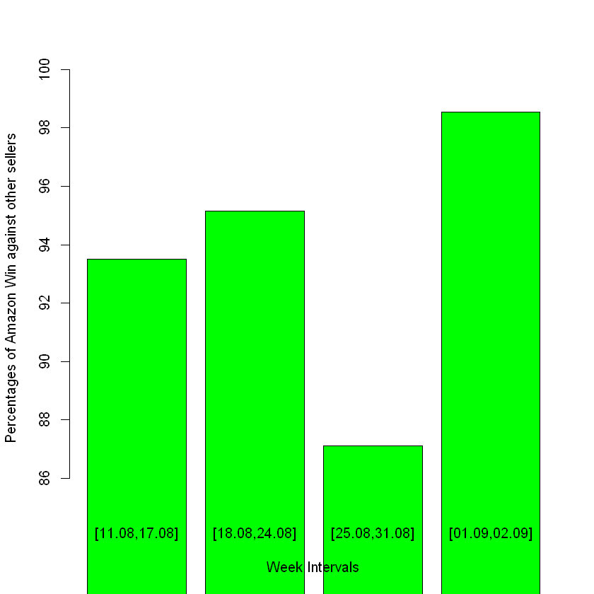

When we divide our total date (23 days) into 4 weeks, we can observe that the percentage of amazon wins against other sellers is very high (they all are above 86%).

1. The rank information in the training data is ranging from 0 to 11. The bar plot of rank vs number of bbox successes are the following:

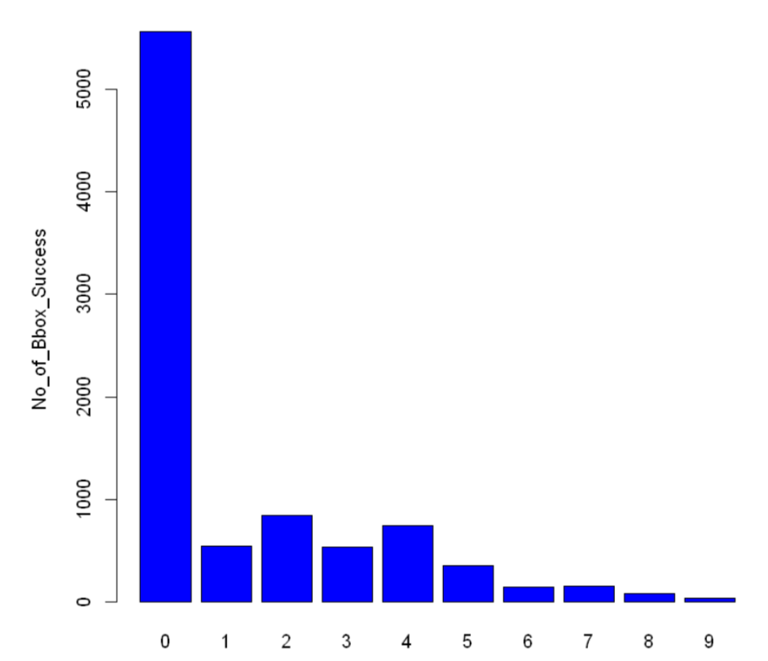

Rank information by seller and by product are given in the “Appendices” section since their tableaus are long. From the plot above, we can say the chance of winning buy box increases as we approach rank 0. When we look at what the rank 0 is we realize that rank 0 occurs when amazon is the seller. This result would not say rank is important in affecting buy box decision if the number of successes had not decreased along x axis.

|  |  |  |
| --- | --- | --- |
| **Product Name** | **Page** | **No. of Bbox Success** |
| B002ZV0OJO | 1 | 1105 |
| B0083H1INK | 1 | 956 |
| B00AMFLZLG | 1 | 1100 |
| B00DNSO1OW | 1 | 1108 |
| B00DNSO41M | 1 | 474 |
| B00MVVI1FC | 1 | 1104 |
| B00VSIT5UE | 1 | 1026 |
| B00VSIT5UE | 2 | 1 |
| B00VSITBJO | 1 | 987 |
| B00VSITBJO | 2 | 101 |
| B00YR6BMS2 | 1 | 1015 |

As can be seen, for the products “B00VSIT5UE” and “B00VSITBJO” the sellers appearing in the buy box are on the first page. However, we cannot say anything about the other products since we do not have their page 2 versions on the training data. Page information by seller can be found in the “Appendices” section again.

To analyze the effect of Prime and Fba on buy bux successes for each product, the tables below are constructed:

|  |  |  |  |
| --- | --- | --- | --- |
| **Product Name** | **Total No. of Bbox Success** | **No. of Bbox==Success and isPrime==Yes** | **Percentage%** |
| B002ZV0OJO | 1105 | 1102 | 99% |
| B0083H1INK | 956 | 956 | 100% |
| B00AMFLZLG | 1100 | 0 | 0% |
| B00DNSO1OW | 1108 | 1108 | 100% |
| B00DNSO41M | 474 | 123 | 26% |
| B00MVVI1FC | 1104 | 0 | 0% |
| B00VSIT5UE | 1027 | 1024 | 99.7% |
| B00VSITBJO | 1088 | 1088 | 100% |
| B00YR6BMS2 | 1015 | 804 | 79.2% |

|  |  |  |  |
| --- | --- | --- | --- |
| **Product Name** | **Total No. of Bbox Success** | **No. of Bbox==Success and isfba==Yes** | **Percentage%** |
| B002ZV0OJO | 1105 | 1102 | 99% |
| B0083H1INK | 956 | 956 | 100% |
| B00AMFLZLG | 1100 | 0 | 0% |
| B00DNSO1OW | 1108 | 1108 | 100% |
| B00DNSO41M | 474 | 123 | 26% |
| B00MVVI1FC | 1104 | 0 | 0% |
| B00VSIT5UE | 1027 | 1026 | 99.9% |
| B00VSITBJO | 1088 | 1088 | 100% |
| B00YR6BMS2 | 1015 | 807 | 79.5% |

From these tables it can be concluded that for most of the products except “B00AMFLZLG”, “B00MVVI1FC” and “B00DNSO41M” Fba and Prime has a strong influence on appearing in the buy box.

Using the same logic, the effect of Prime and Fba on buy bux successes for sellers are shown as follows:

|  |  |  |  |  |  |  |
| --- | --- | --- | --- | --- | --- | --- |
| **Seller Id** | **# Bbox Success** | **# Bbox==Success and isPrime==Yes** | **%** | **# Bbox Success** | **# Bbox==Success and isfba==Yes** | **%** |
| A1CPWE4BUHBCWE | 15 | 15 | 100% | 15 | 15 | 100% |
| A1L9D0A8YQ4I2J | 52 | 52 | 100% | 52 | 52 | 100% |
| A1LLDJOGLVSHKP | 17 | 17 | 100% | 17 | 17 | 100% |
| A1NNAMFIGL0WW | 1 | 1 | 100% | 1 | 1 | 100% |
| A1P24ZYMPUKXCC | 18 | 18 | 100% | 18 | 18 | 100% |
| A22RMSXAK08YRI | 8 | 8 | 100% | 8 | 8 | 100% |
| A2BTS1X5W6FOE2 | 29 | 29 | 100% | 29 | 29 | 100% |
| A2TC87EJKQMY9O | 31 | 19 | 61.3% | 31 | 22 | 71% |
| A33ZYGKLC0HPSW | 7 | 7 | 100% | 7 | 7 | 100% |
| A3HZNJ7XC4ABL8 | 52 | 52 | 100% | 52 | 52 | 100% |
| A3SQ9YFE6CSCS0 | 551 | 551 | 100% | 551 | 551 | 100% |
| A7Q70VOZ5QTKB | 6 | 6 | 100% | 6 | 6 | 100% |
| A9X5UX7R2WF5U | 7 | 7 | 100% | 7 | 7 | 100% |
| amazon | 5423 | 5423 | 100% | 5423 | 5423 | 100% |
| A1ZI2ITZC97U95 | NA | NA | NA | 2 | 2 | 100% |

From these tables we understand that the sellers having Prime and Fba appear in the buy box mostly.

1. In part b, we see that the price information is an important factor for appearing in the buy box. For example, the seller who offers less price has a better chance to win. Therefore, in order to give this information to our data, the price column in the training data is changed as follows:

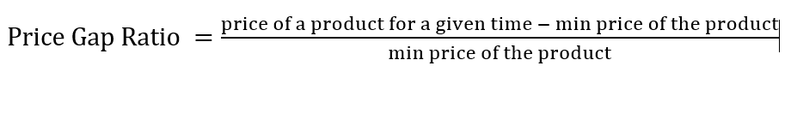

We know that buy bux prices follow the min price for most of the products. Therefore, with this formulation we want to measure how far a product’s price is from the product’s min for a given time. So it can be seen that the larger the price gap ratio the less chance to win the buy box. In this way we make the price scales smaller which is usually necessary in the problems containing data. Otherwise, it can dominate other features just because its values while it is not an important feature, for example.

In addition, shipping costs are usually playing a key role in our decision process. When we want to buy a product and pick a seller we consider not only the seller’s price but the price containing the seller’s shipping cost. In order to put this information to our data and model we create another feature called “total weighted cost” using the formula below:

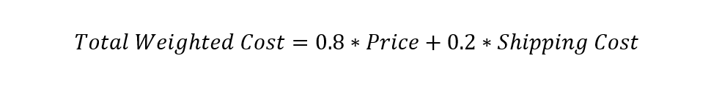

The weights are selected by our personal experiences. Since we give more importance to the price in the online shopping process we select 0.8 for this feature. We think that this feature will be beneficial in creating different models for each product since the price values are product dependent. In this project, we create only 1 model. Therefore, we did not include this feature but we put this idea for future work.

We have 17 columns in our training data. Some of them such as is_prime, is_fb, bbox,etc are factor variables and some of them are continuous variables. The table that summarizes these properties are given below:

|  |  |
| --- | --- |
| **Feature Names** | **Classes and Scales** |
| pid | character(9 different sellers) |
| month_days | character(23 different days) |
| sid | character(184 different sellers) |
| price | continuous (min: 74.99, max:1633.60) |
| sid_rating | continuous (between 0 and 5) |
| sid_pos_fb | continuous (between 0 and 10) |
| sid_rating_cnt | continuous(between 0 and 100) |
| shipping | continuous (min:0, max:59.17) |
| page | factor (1or 2) |
| rank | factor (ranging from 0 to 11) |
| pid_rating | continuous (between 0 and 5) |
| pid_rating_cnt | continuous(between 0 and 1) |
| is_fbs | factor (yes/no) |
| is_prime | factor (yes/no) |
| bbox_sid | character (184 different sellers) |
| bbox_price | continuous (min:74.99,max:159) |
| bbox | factor (failure,success) |

1. When we do some analysis to detect outliers, we realize that there are many outliers in the training data. For example, pid_pos_fb column has outliers:

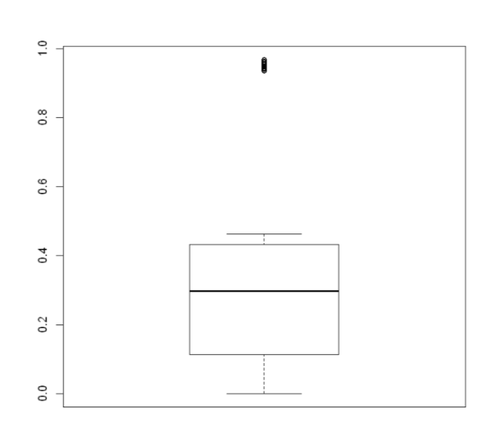

The outliers are product 'B00DNSO1OW' and product 'B00DNSO41M'. If we remove them from the training data it may cause loss of information for these products. Therefore, we decided to keep the outliers in the data.

**2.**

In part d, It is found that amazon wins the buy box with approximately 92% percent against the other sellers. So, we decided to convert the “sid” column to a binary feature called “is_Amazon” to specify whether the seller is amazon or not. In addition, from our experience on the training data, the boy bux price should be close to the minimum price. Therefore, we want to add “price gap ratio” feature to our data. Also, in part c, we found that sid_rating, sid_rating_cnt, and sid_pos_fb are the important factors on appearing in the buy box. From our personal experience, we know that sid_rating and sid_pos_fb are highly correlated with each other.

When we construct a correlation table among them, the result occurs exactly the way we expected:

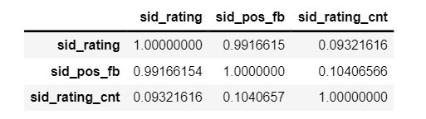

Therefore, we want to choose one of them to construct a model. We construct a basic Random Forest model to understand which one of them is a more important feature. The results are the following:

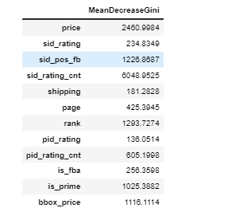

In Random Forest models, the larger the gini index the more important the feature. As can be seen, the gini index of sid_pos_fb is higher than the index of sid_rating. Therefore, we decided to select sid_pos_fb as one the nodes in our model.

Then, we also found that is_fba and is_prime features are also important features for 5 of the 9 different products. In addition, we realized that a small number of sellers other than amazon have is_prime = yes and is_fba = yes property. Therefore, we thought that it is better to put “is_Amazon” feature since it mostly contains the is_fba and is_prime information. Therefore, in this part we decided not to include these factors to keep the model as small as possible. Also, in part e, we realized that rank is important and the chance of winning increases as we approach rank 0. Therefore, this will be included in our model.

Since other columns such as product rating or product rating count are dependent on the product type we discard these informations from our model. We also remove the informations of “epoc” and “pid” since they have nothing to do with the bbox column.

As a result our single final model will contain is_Amazon, price gap ratio, rank, sid_pos_fb and the output variable bbox.

**3.**

**Five different methods (Hill Climbing, Tabu Search, Grow Shrink, Incremental Association and Max-Min Hill Climbing) which are scored-based, scored-based, constraint-based, constraint-based and hybrid algorithms respectively, are used to learn structure of BN with a given train data.**

**After whitelist and blacklist created, all algorithms make the same DAG and score. Then, cross-validation is made with two different methods (k-fold and hold-out). Tabu search algorithm expects minimum loss on both methods against other methods. Boosttrapping is also give the same DAG with tabu search. Thus, tabu search algorithm is used for the rest of the study.**

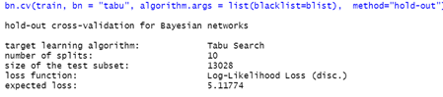

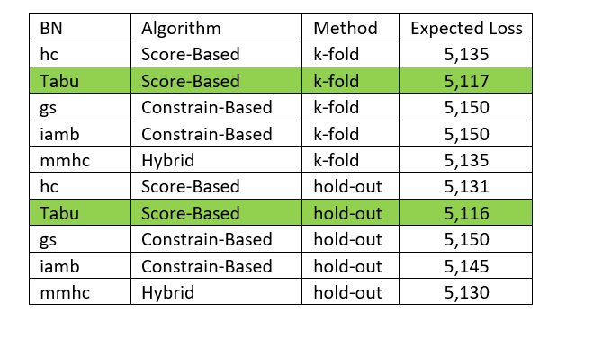

"is_Amazon", "price_gap_ratio", "sid_pos_fb", "rank" and "bbox" parameters are used to learn DAG. "price_gap_ratio", and "sid_pos_fb" parameters does not discrete and it is known that continues nodes cannot be parent of discrete nodes. Therefore, our model tends to be misinterpreted. To prevent this problem these two parameters transformed to discrete by making intervals so that it can be treated as factor.

While converting continues parameter to discrete intervals, two factor is considered. The first one is expected importance of value. For instance, customer’s decision may not change if the “sid_pos_rate” is 9.9 or 9.8. Therefore, we start with 0.5 interval but end with 0:7 interval since it does not make importance once it goes below 7. The second factor is almost equally and large enough sized interval. This part is important. If there is no data on train corresponding to test observation, algorithm cannot predict that test observation. To solve that interval length should be increased. However, to increase the effect of parameter interval length should be decreased. Here, it is tried to find optimum interval values which maximize the prediction accuracy.







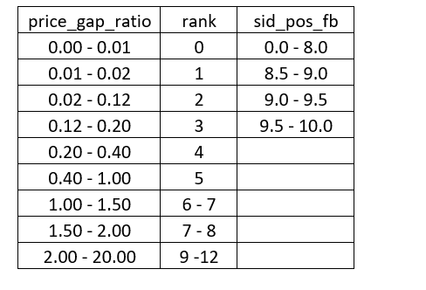

First DAG does not seem good model since we know some information between parameters. Therefore, whitelist and blacklist are used to force wanted arc and prevent unwanted arcs between parameters.

We are making whitelist and blacklist with the highest possible and logical information between nodes since learnt DAG is heuristic depends on whitelist and blacklist approval order. We start with whitelist since it is superior of blacklist. We expect all of chosen parameters should affect bbox. Therefore, we make whitelist for these and then continue to for the rest. The final whitelist and blacklist can be shown in below table.

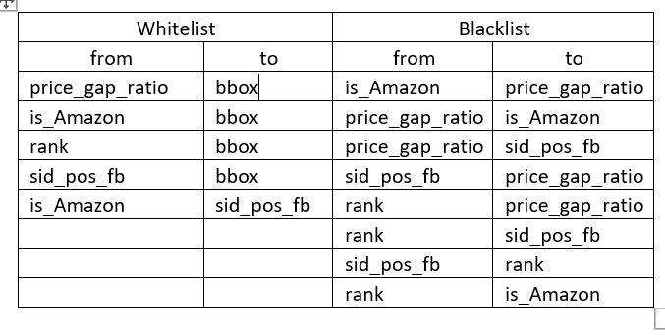

4.

There are 2*2*9*9*4 parameters of the model that are learnt by using training data. Since there are many parameters, only few of them are shown in the below section.

is_Amazon

bbox 0 1

failure 0.9959866221

success 0.0040133779

, , price_gap_ratio = (0.4,1], rank = (2,3], sid_pos_fb = (9,9.5]

is_Amazon

bbox 0 1

failure 0.9969040248

success 0.0030959752

, , price_gap_ratio = (1,1.5], rank = (2,3], sid_pos_fb = (9,9.5]

Parameters of node price_gap_ratio (multinomial distribution)

Conditional probability table:

, , price_gap_ratio = [0,0.01]

is_Amazon

rank 0 1

[0,1] 0.365258462 0.935327635

(1,2] 0.188664393 0.006837607

(2,3] 0.121315490 0.023361823

(3,4] 0.116767253 0.001709402

(4,5] 0.059302020 0.015099715

(5,7] 0.057990029 0.017663818

(7,9] 0.060788944 0.000000000

(9,12] 0.029913409 0.000000000

, , price_gap_ratio = (0.01,0.02]

is_Amazon

rank 0 1

[0,1] 0.077611940 0.005665722

(1,2] 0.101256874 0.056657224

(2,3] 0.107541241 0.314447592

(3,4] 0.097486253 0.235127479

(4,5] 0.103534957 0.198300283

(5,7] 0.207227023 0.184135977

(7,9] 0.207069914 0.005665722

(9,12] 0.098271799 0.000000000

Parameters of node sid_pos_fb (multinomial distribution)

Conditional probability table:

is_Amazon

sid_pos_fb 0 1

[0,8.5] 0.0989359 0.0000000

(8.5,9] 0.1176300 0.0000000

(9,9.5] 0.1887658 0.0000000

(9.5,10] 0.5946682 1.0000000

b-) The success probability of winning bbox of amazon as a saler P( bbox=success | sid=amazon ) is calculated as 86.7% with below function:

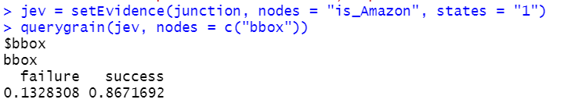

c-) Firstly, prediction model with the chosen dag and parameters ("is_Amazon", "price_gap_ratio", "sid_pos_fb" and "rank") is created. Then, prediction made with training data to see the accuracy level of model and it is calculated as 98.3%. Once test result are uploaded, prediction made with test data on the same prediction model similarly. The accuracy of test model predictions calculated as 93.85%. Confusion matrix of both train and test data prediction results are shown in the below:

d-)

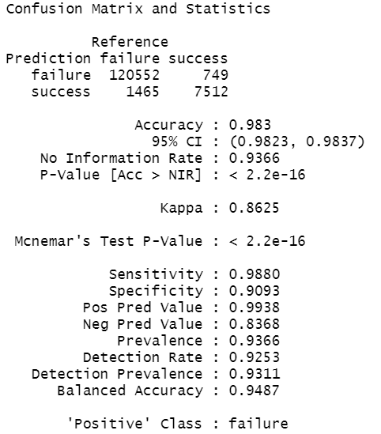 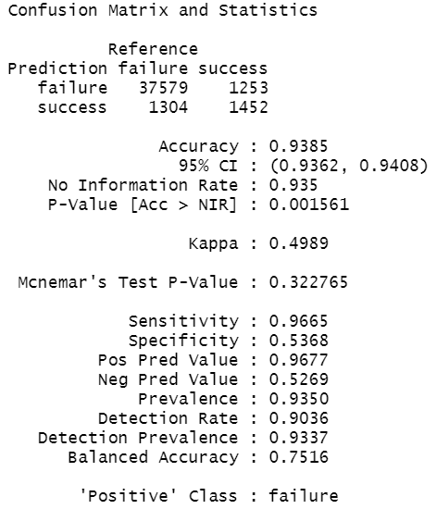

**Appendices:**

**Rank information by seller:**

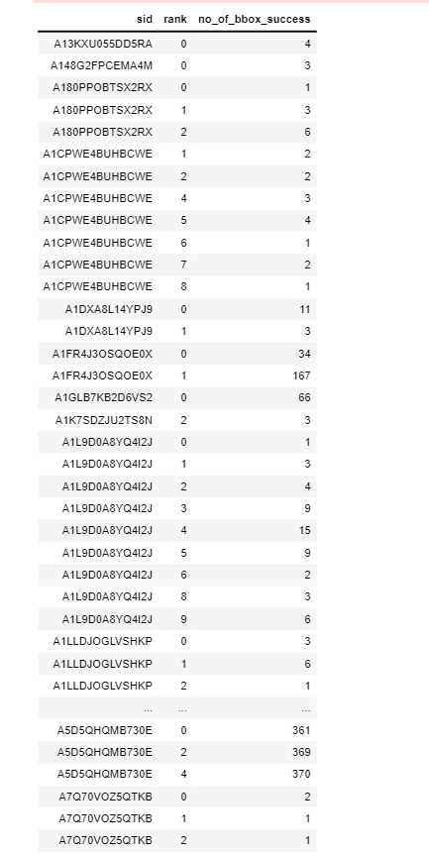

**Rank information by product:**

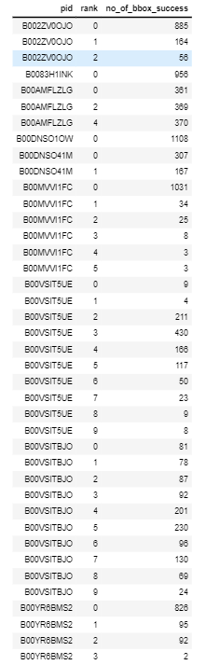

**Page information by seller:**

